**Distribution of Nonnative Plant Species in Northeastern Washington and Adjacent Idaho: Implications for Restoration Planning**

**Rachel Salazar, Neville Magone, and James G. Hallett |Biology, Eastern Washington University**

**Introduction**

Nonnative plants species are a significant problem in disturbed or degraded habitats. Nonnative species include noxious species as well as nonnative plants that do not act invasively. Invasive or noxious species are organisms that have life-history characteristics that allow them to outcompete native species. This may result in reduced biodiversity and ecosystem services. Degraded ecosystems are highly susceptible to invaders, and management for invasive species are economically costly. Annual costs to control invasive species in the U.S., for example, are approximately $138 billion (Bryson and Carter 2008). Ecological restoration efforts are being implemented regionally to reduce disturbance and restore native flora and fauna.

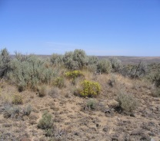

A

B

As part of this effort, we examined the composition and distribution of grass and forb species in the Inland Northwest using data from a long-term monitoring program. Our objectives were to first characterize the composition of the nonnative flora, and the relative importance of these species to the overall flora. Second, we asked how the composition of areas undergoing ecological restoration (mitigation sites) compares to sites that reflect a desired future condition (reference sites).

**Study Areas**

Mitigation sites were managed by the five Upper Columbia Tribes in eastern Washington and northern Idaho (Fig.1). Reference sites were on lands managed by the BLM, Turnbull National Wildlife Refuge, Spokane Tribe, and Kalispel Tribe (Fig. 1).

Sampling was conducted on 68 mitigation sites for eight habitat types: emergent wetland (5 sites), wetland meadow (30, Fig. 2A), riparian shrub (6), riparian forest (3), grassland steppe (6), shrub-steppe (5, Fig. 2B), conifer woodland (6), and mixed conifer (7).

An additional 24 reference sites were chosen as the best intact representatives of each habitat type.

Sites were chosen by superimposing a 200-m grid over a map of the mitigation areas and taking a randomly-stratified set of points.

Sampling was conducted in 2002-2006 and 2009-2013.

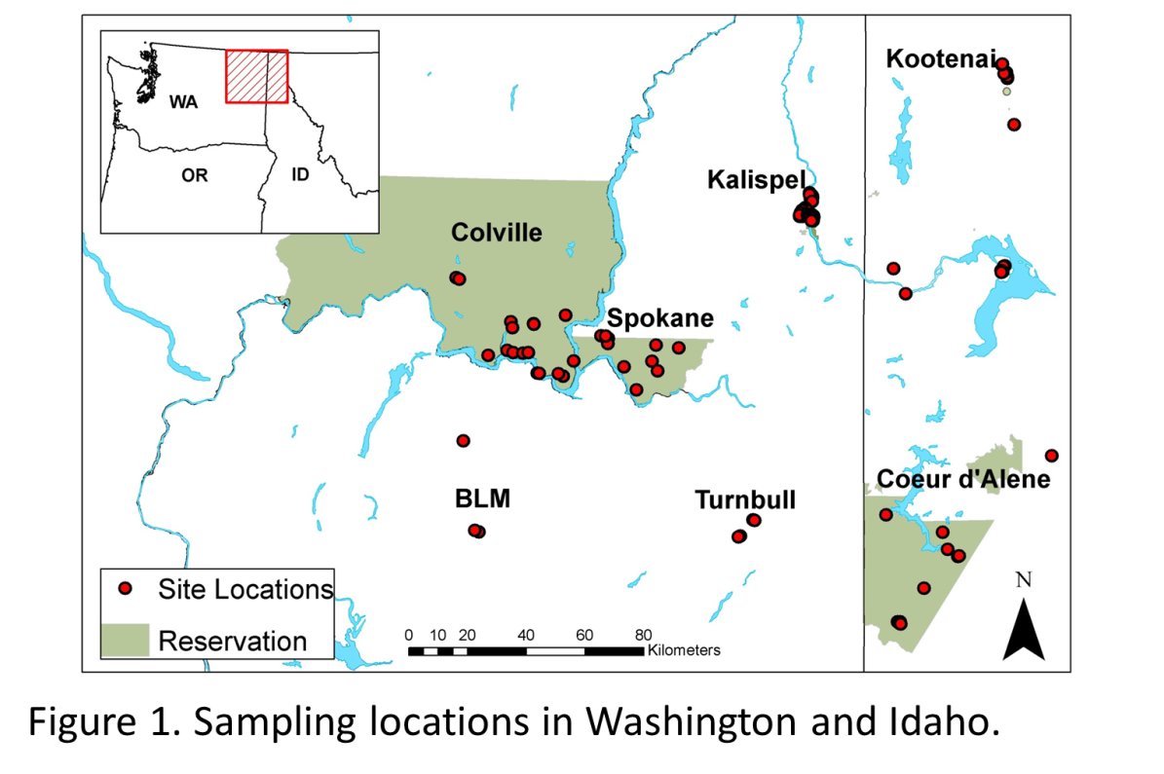

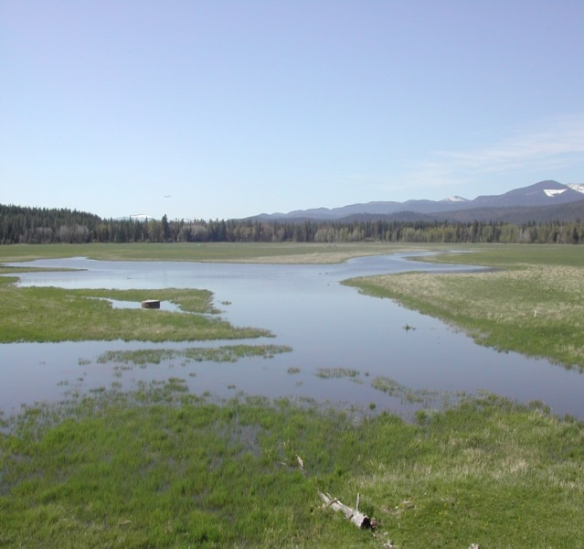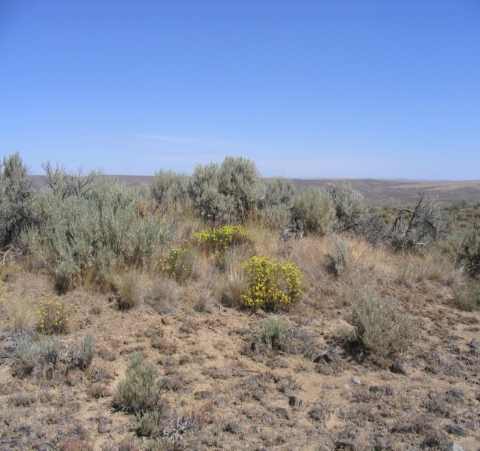

A

B

Figure 2. Field work was conducted on four riparian-influenced and four upland habitats. (A) Wetland meadow. (B) Shrub-steppe.

**Methods**

*Field Sampling*

Cover was estimated using 33 20 × 50-cm plots on 32-m transects centered on each sampling point following Daubenmire (1959).

Plants were identified to species and assigned native status using USDA database.

Total areal extent of each species was calculated to represent relative abundance.

*Data Analysis*

We constructed frequency plots to examine the prevalence of non-native species and the proportion of noxious species.

Using R (Version 3), we calculated a dissimilarity matrix using Chao-Jaccard values (Chao et al. 2005) based on the relative abundance of each plant species at each site. Non-metric multidimensional scaling (NMDS) helps to understand the relationships of the sampling sites using this matrix.

We used a permutation test to perform an analysis of variance on the partitioned dissimilarity matrix (adonis in the vegan package for R).

**Results**

*Species composition*

We observed a total of 313 species from 53 plant families (n = 15,993 individual observations). Over 50% of all species were in eight families listed in decreasing order of abundance: Poaceae, Asteraceae, Cyperaceae, Fabaceae, Plantaginaceae, Ranunculaceae, Polygonaceae, and Rosaceae. Nonnative plants were represented by 85 species in 23 families with 5 families represented only by nonnative taxa (Fig. 3). Eighteen species in 7 families were classified as invasive.

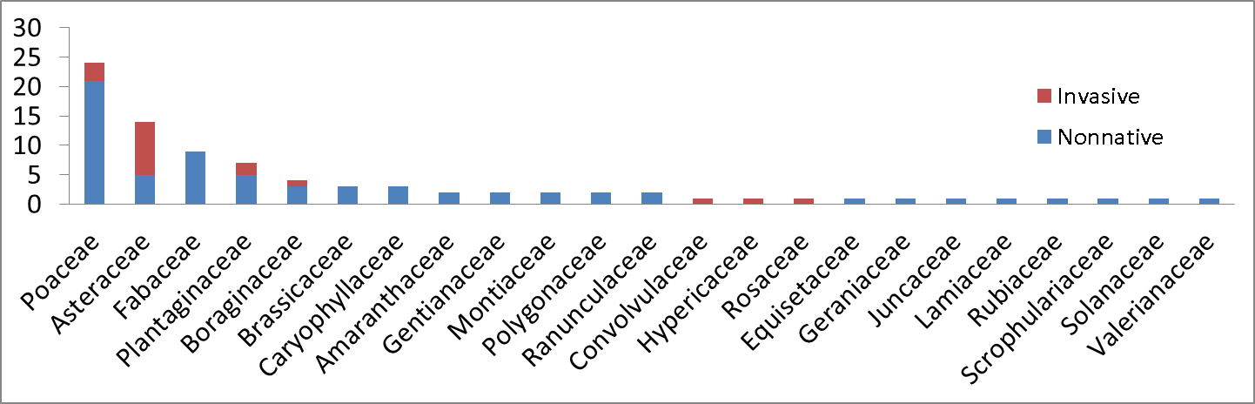

Figure 3. Numbers of nonnative and invasive species in each family.

The incidence of nonnative plants in the species pool varied from 0 to 100% across all sampling units. The only sites without any nonnative plants were emergent wetlands dominated by cattails (Typha latifolia). Nonnative plant species comprised >25% of flora for most sites (Fig. 4). Over 50% of sites (n = 47) had >50% nonnative species. The proportion of nonnative species varied with habitat and geographical location (Fig. 5).

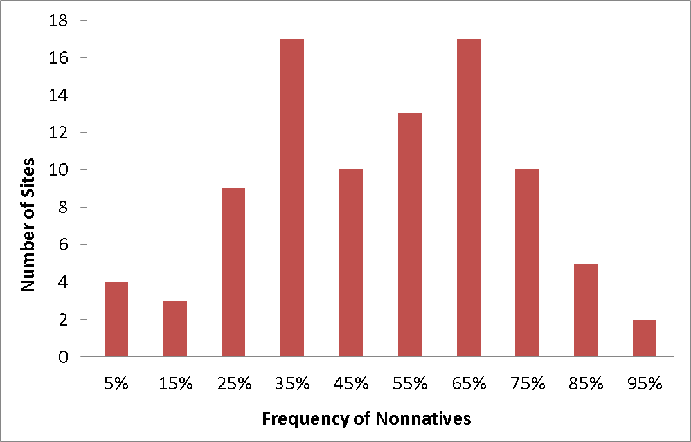

Figure 4. Distribution of sites relative to the contribution of nonnative plant species to the species pool.

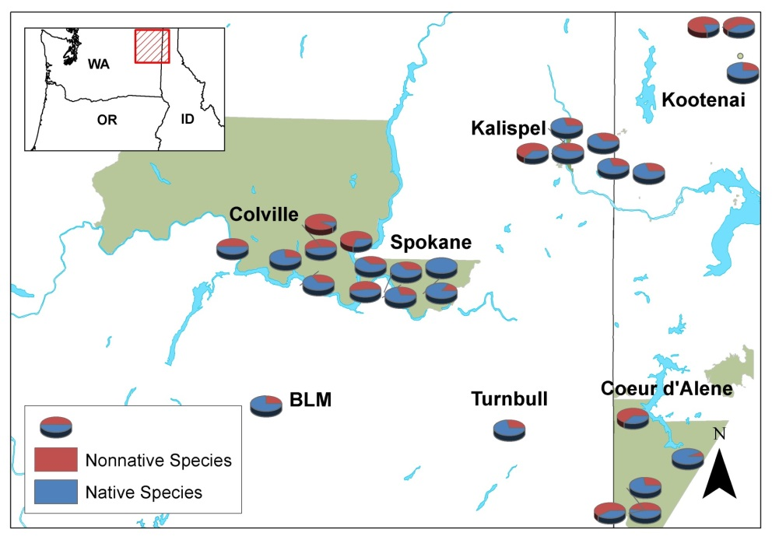

Figure 5. Proportions of native and nonnative species for each habitat type and ownership.

*Community similarity*

NMDS plots for most habitat types showed some variation among reference sites in plant species composition, but much less than observed for mitigation sites (Fig. 5A, B). This indicates much greater divergence in the composition of the plant communities on degraded lands.

Likely due to the greater variation observed for mitigation sites, differences between reference and mitigation sites were significantly different only for shrub-steppe and grassland-steppe habitats (adonis, P < 0.05).

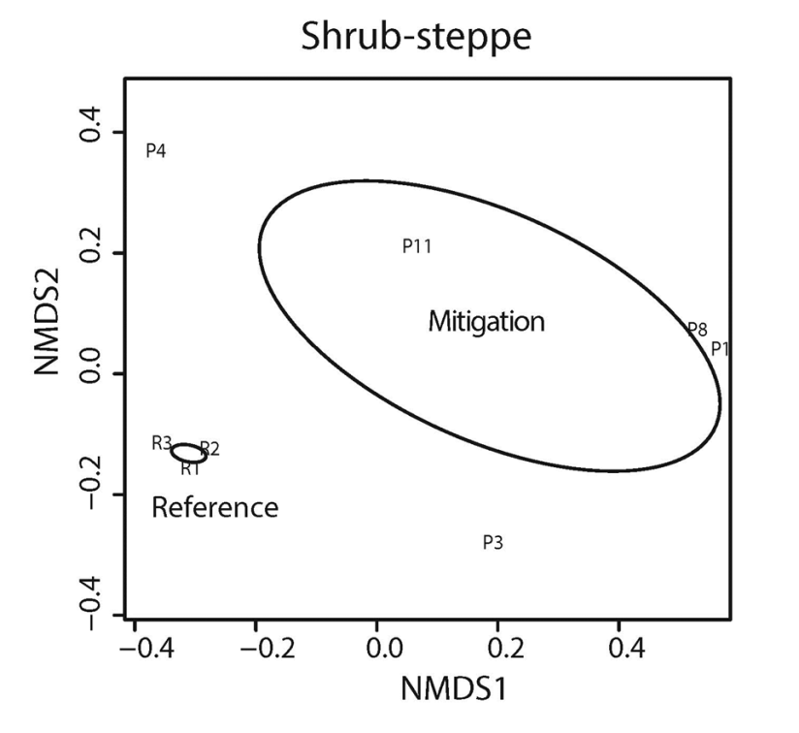

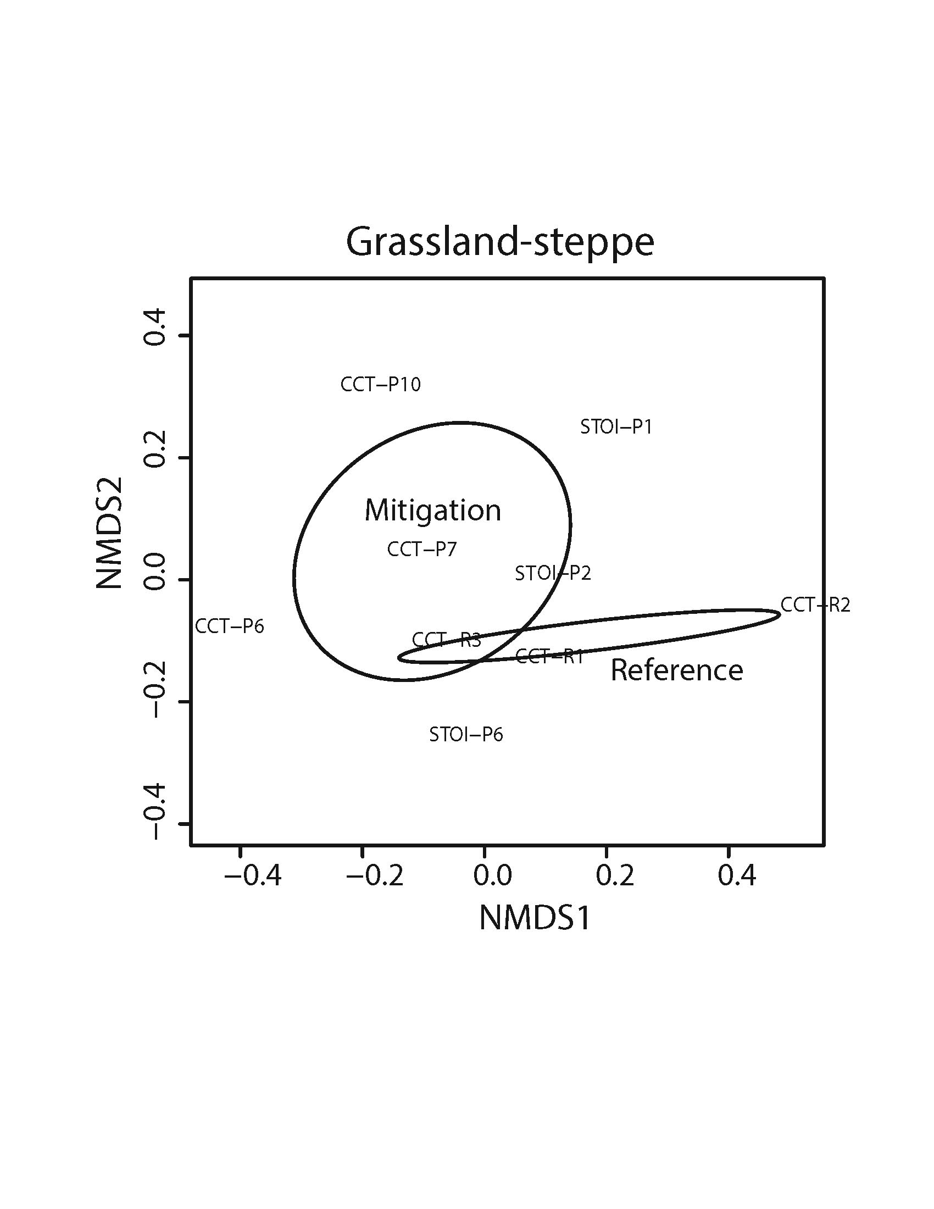

Figure 6. Contrasts between mitigation and reference sites of specific habitats based on dissimilarity between sites. (A) Shrub-steppe. (B) Grassland-steppe.

**Discussion**

Nonnative plants were observed on almost all reference and mitigation sites and for all habitat types. Very few sites had a species composition with <20% nonnative species and most had >50% (Fig. 4). Although infrequent in our dataset, some sites were entirely dominated by nonnative species such as Phalaris arundinacea (reed canarygrass). We did not anticipate such high proportions of nonnative species in the flora, and they reflect high levels of disturbance and degradation of many landscapes. Although there are many causes of degradation, intense grazing, overharvesting, and abandonment of agricultural fields were the dominant forces for most sites in our study.

Land degradation has significant consequences in terms of (1) loss of biodiversity; (2) reduction or loss of ecosystem services necessary for human health, food and water security, and culture; and (3) the strong relationship between poverty and degree of land degradation (Wortley et al. 2013). Our comparisons of mitigation sites undergoing ecological restoration with reference sites suggests that our strategies for restoration may have to be tailored to particular sites to a greater extent than currently practiced. The typically high variation in plant composition on mitigation sites means that the trajectories of these sites toward the reference condition are likely to differ. Because no single prescription for ecological restoration is likely to be successful at all locations for a given habitat, we believe that it is essential to monitor the changes following restoration activities to determine how the initial conditions (i.e., plant composition) determine the outcome. In some cases, small scale experiments might be preferred prior to initiating restoration.

**Literature Cited**

Bryson, C. T. and R. Carter. 2008. The significance of Cyperaceae as weeds. Pages 15-101 in R. F. C. Naczi and B. A. Ford, editors. Sedges: Uses, Diversity and Systematics of the Cyperaceae. Monographs in Systematic Botany from the Missouri Botanical Garden,108.

Chao, A., R. L. Chazdon, R. K. Colwell, and T.-J. Shen. 2005. A new statistical approach for assessing similarity of species composition with incidence and abundance data. Ecology Letters 8:148-159.

Daubenmire, R. 1959. A canopy-coverage method of vegetation analysis. Northwest Science 33:43-64.

Wortley, L., J.-M. Hero, and M. Howes. 2013. Evaluating ecological restoration success: a review of the literature. Restoration Ecology: 21:537-543.

**Acknowledgments**

Kristi Kimmet assisted in all aspects of field sampling, plant identification, and database management. Many students were involved in field data collection. Natural resource and wildlife staffs of all five Tribes provided logistical support. Funding was provided by the Bonneville Power Administration through the Upper Columbia United Tribes to J.G. Hallett and M.A. O’Connell.

